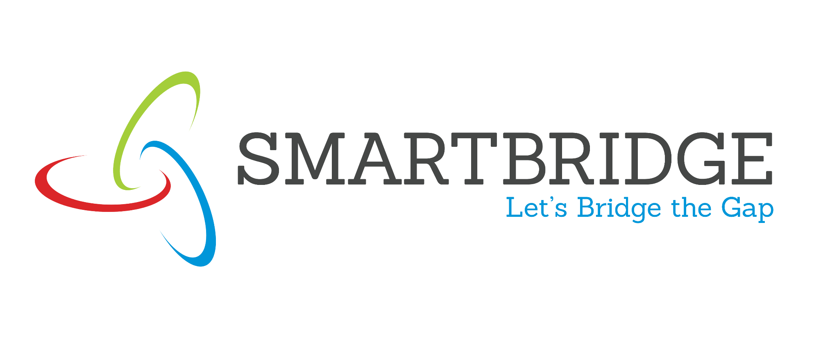

Project Initialization and Planning Phase

Date | 15 March 2024
Team ID | SWTTD-2026-8485
Project Name | LEGALEASE-AI
Maximum Marks | 3 Marks

Define Problem Statements (Customer Problem Statement Template):
Create a problem statement to understand your customer's point of view. The Customer Problem Statement template helps you focus on what matters to create experiences people will love. A well-articulated customer problem statement allows you and your team to find the ideal solution for your customers' challenges. Throughout the process, you’ll also be able to empathize with your customers, which helps you better understand how they perceive your product or service.

Example:
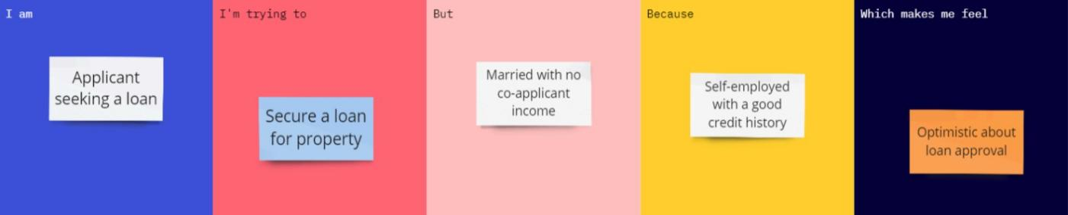

LegalEase AI – Project Details
Date: 30 September 2026
Team ID: SWTID-2026-8485
Project Name: LegalEase AI
Team Members: Janasakthi.M;Kishor.S;Girivasan.D

